|  |  |  |  |  |  |  |  |
| --- | --- | --- | --- | --- | --- | --- | --- |
| AIUB | **American International University- Bangladesh (AIUB)**  **Faculty of Engineering** | | | | | | |
|  | |  | | |  | |  |
| **Course Name :** | | Electronic Devices | | | **Course Code:** | | EEE 2103 |
| **Semester :** | | Spring 2020-21 | | | **Section:** | | J |
| **Faculty :** | | Dr. Md. Rifat Hazari | | |  | |  |
|  | |  | | |  | |  |
| **Assignment No :** | | 1 | | | | | |
| **Assignment Name :** | | CO2 (POI: P.a.3.C3) | | | | | |
|  | |  | | |  | |  |
| **Student Name:** | | **NAFINUR LEO** | | | **Student ID:** | | **20-42195-1** |
|  | |  | | |  | |  |
|  | | | |  |  | |  |
| **Submission Date:** | | | **20-02-2021** | | **Due Date :** | **20-02-2021** | |
|  | | | |  | | | |

**Marking Rubrics (to be filled by Faculty):**

|  |  |  |  |  |  |  |  |
| --- | --- | --- | --- | --- | --- | --- | --- |
| Problems | Excellent  [5] | Proficient  [4] | Good  [3] | Acceptable  [2] | Unacceptable  [1] | No Response  [0] | Secured Marks |
| **Problem 01** | Detailed unique response explaining the concept properly and answer is correct with all works clearly shown. | Response with no apparent errors and the answer is correct, but explanation is not adequate/unique. | Response shows understanding of the problem, but the final answer may not be correct. | Partial problem is solved; response indicates part of the problem was not understood clearly. | Unable to clarify the understanding of the problem and method of the problem solving was not correct. | No Response |  |
| **Problem 02** | Detailed unique response explaining the concept properly and answer is correct with all works clearly shown. | Response with no apparent errors and the answer is correct, but explanation is not adequate/unique. | Response shows understanding of the problem, but the final answer may not be correct | Partial problem is solved; response indicates part of the problem was not understood clearly. | Unable to clarify the understanding of the problem and method of the problem solving was not correct | No Response |  |
| **Comments** |  |  |  |  |  | Total marks (10) |  |

***INSTRUCTIONS: When a question mentions “ID” as a value, you have to use the last two digits of your ID before the hyphen. For example, for 12-34567-8 it would be 67. If the last 2 digits of your ID form a number less than 10, then add 10 with the number before using it to solve the problems. If the last 2 digits of your ID form a number greater than or equal to 10, you can use it as it is.***

***Note: Copied/identical submissions will be graded as 0 for all parties concerned.***

**Problem 1**

Consider that the input shown in the below figure (here Vx = **ID** V). **[5]**

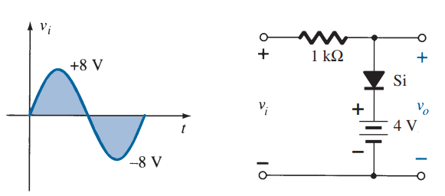

**Vx**

**-Vx**

**x**

***Fig. 1***

Apply the knowledge gained from diode theories to **construct a circuit** which satisfies the following conditions and **sketch the output voltage** of the constructed circuit. Please explain how your circuit works and state your reasoning for your choice of circuit.

**Design Criteria:**

1) Only regular diodes (choose between Ge, Si, GaAs) and resistors can be used to construct the network.  
2) During positive half cycle, output VO = (Vi – 1.2 V)  
3) During negative half cycle, output VO = 0 V  
4) Diode Peak inverse voltage = Vx

**Problem 2**

Consider that the input shown in the below figure (here Vx = **ID** V ).  **[5]**



**3 V**

**Ge**

-**Vx**

**Vx**

***Fig. 2***

Apply the knowledge gained from diode theories, **determine Vo curve** and explain the operating principle of the circuit shown in Fig. 2.

